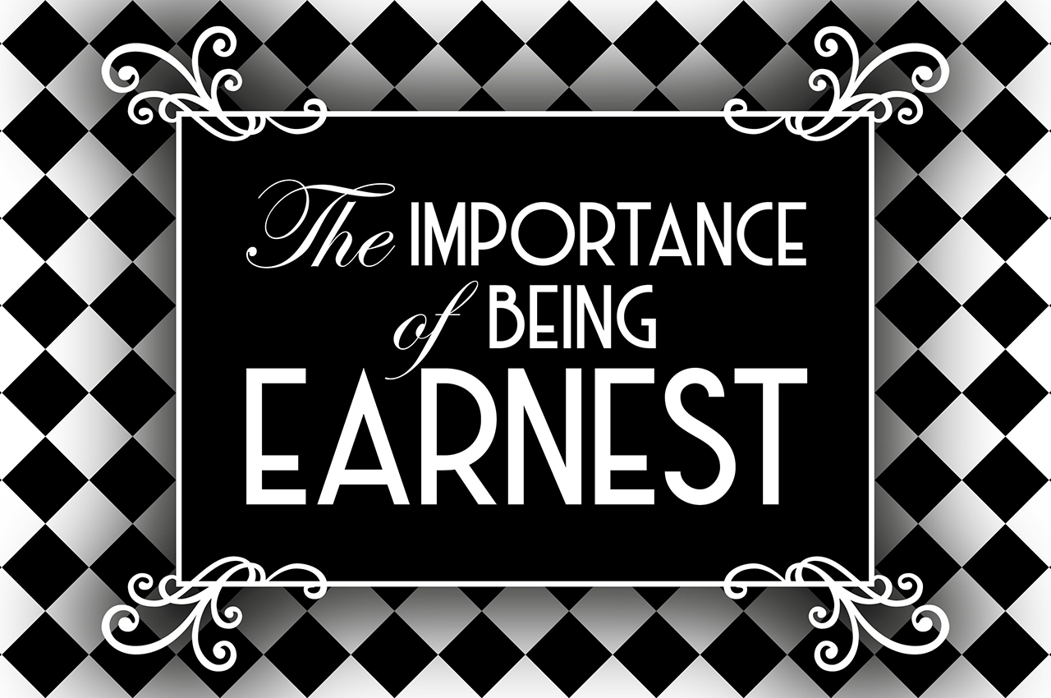
libero adattamento dall’opera di Oscar Wilde
Director:
EVA SAVAGE
Managing director:
JOHN O’CONNOR
Cast:
TOM BLACKMORE – JODIE GARNISH
CARA MAHONEY – GEORGINA RUSSELL – PAUL THIRKELL
PLOT
Jack Worthing is a rich young man who uses the alter ego of Ernest when he is in London. He falls in love with his friend Algernon Moncrieff’s cousin, Gwendolen, who has always wanted to marry a man with his name. When Algernon goes to the country and meets Cecily, he introduces himself as Jack’s wicked brother, Ernest. Both girls believe they are engaged to a man called Ernest. Jack, who does not know who his parents are, discovers that he is indeed Algernon’s brother and that his true name is Ernest. In the end the two couples ……….
Saturday, 8th February 2020 at 10:00

